Media Contacts:
Judi Shils, Coastal Commission, judishils@earthlink.net, 415.939.1232 cell
Dawn Stranne (SF) dawn@pr-dsa.com, 415.893.1780 or 415.533.0532 cell
Toni Purry (OC/Dana Pt) toni.purry@purry.com, 310.410.0300
Maria Losch (Santa Monica) maria@marialosch.com, 310.592.6724 cell

California Coastal Commission Reveals Winners of
Public Contest to Design New Whale Tail® Ecoplate

Co-winners hail from Laguna Beach and Northern California’s Delta

(SAN FRANCISCO/SANTA MONICA/DANA POINT, Calif., August 2, 2011) – Out of more than 300 entries in a contest created by the California Coastal Commission to engage the public’s help in designing a new Whale Tail® Ecoplate for the State of California, the Commission chose two winners: Bill Atkins, a graphic designer and illustrator from Laguna Beach, Calif., and Elizabeth Robinette Tyndall, a painter who lives in Bethel Island on Northern California’s Delta in Contra Costa County. The Coastal Commission invited the artists to collaborate on a new Whale Tail® image, combining facets of each of their winning designs. A team of graphic designers made final refinements.

To thank them for their efforts, the Coastal Commission rewarded each artist with $1,000, and invited them to attend the Whale Tail® Ecoplate press conferences on August 2.

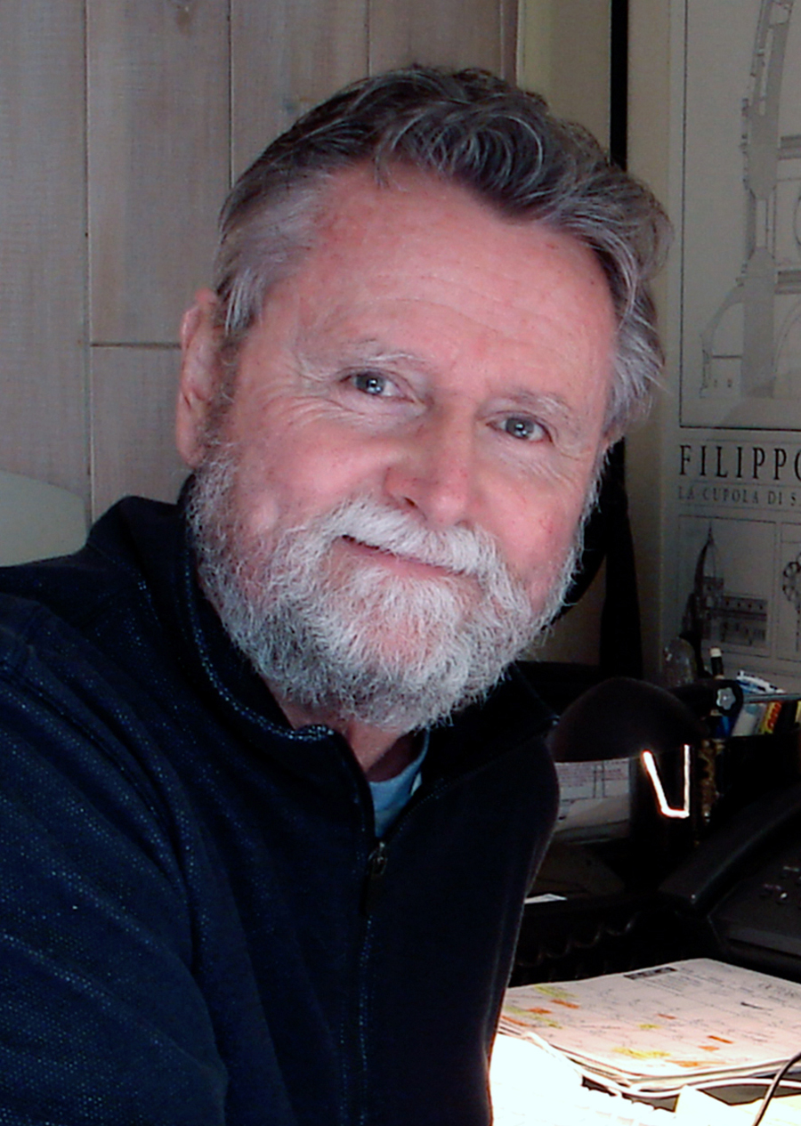
Bill Atkins
Trained in traditional media, Bill evolved into digital media 15 years ago. Since that time, he has worked individually and collectively on a variety of socially engaged interdisciplinary projects over the years. Some of his clients include: The City of Irvine, Orange Coast River Park, and South Coast Water District, all located in Orange County. Additionally, he has created nearly 100 entertainment posters to promote talent at the Agua Caliente Casino, Resort and Spa in Rancho Mirage, Calif. Other activities include developing graphic art campaigns to promote and support fund raising efforts for Laguna Art Museum, AIDS Services Foundation, Orange County, and poster designs to assist the local chapter of Human Rights Campaign. He currently teaches Graphic Design at Irvine Valley College. Bill’s website is Lagunaposter.com.

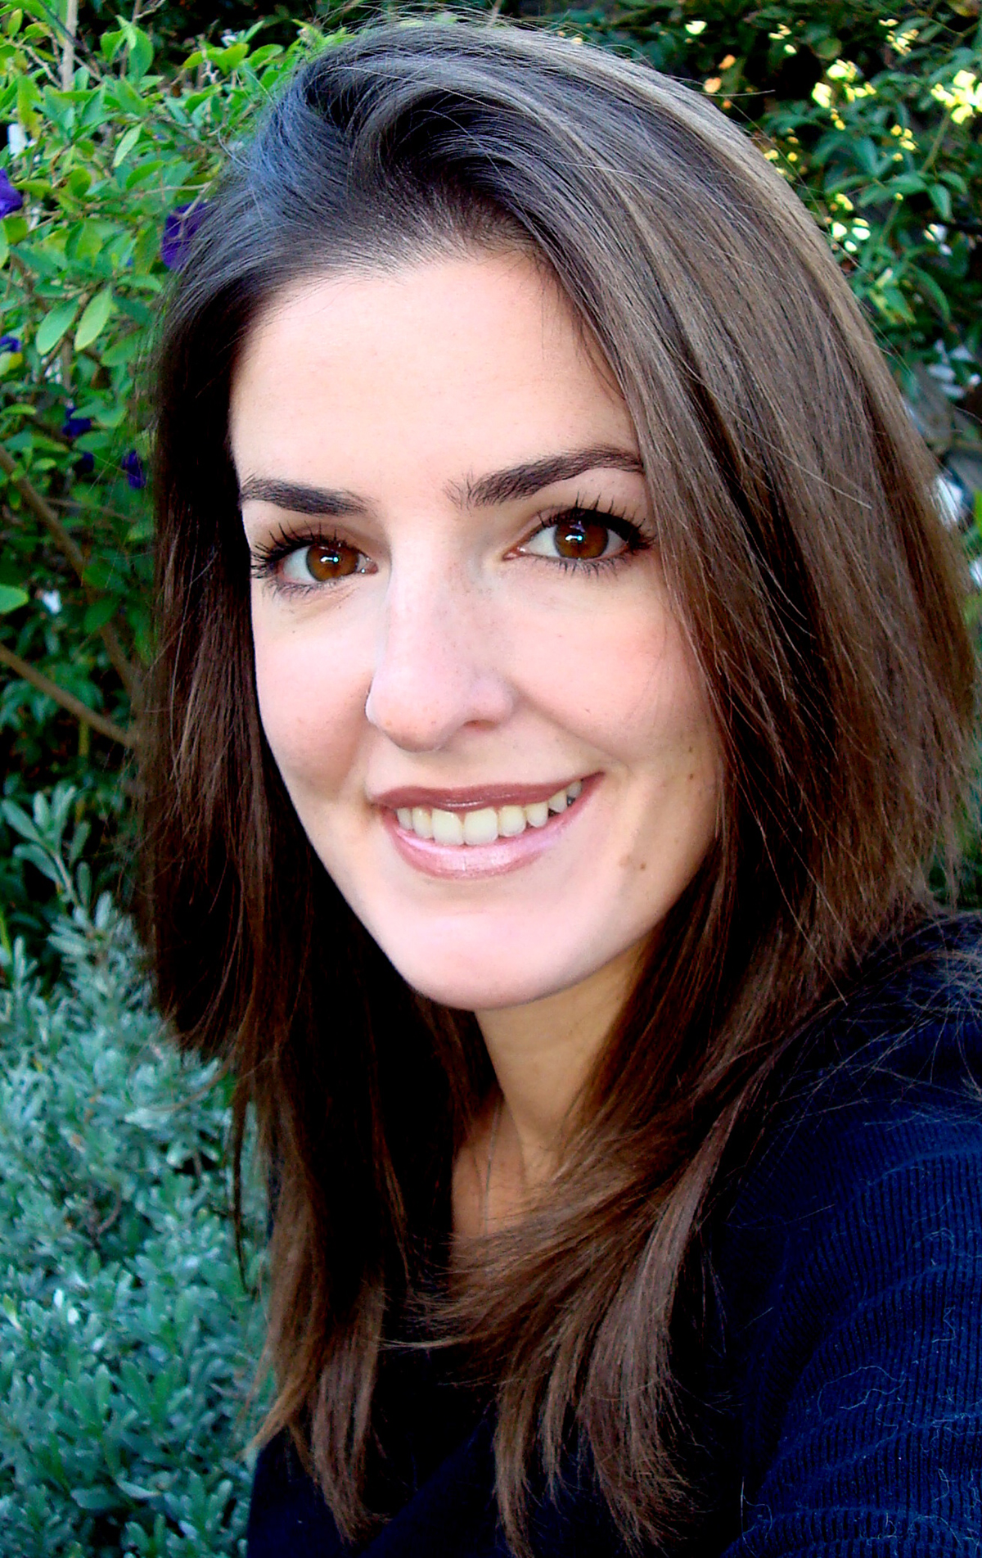
Elizabeth Robinette Tyndall
Elizabeth specializes in landscape paintings, beach and boat scenes, florals, California Delta art, and home décor art. Most of her inspiration comes from living on the Delta, where one of her favorite challenges is capturing the presence of reflective water through light. She has been a painter for more than 16 years, but has also enjoyed working as a florist for eight years, along with teaching and caregiving. Elizabeth’s love for nature is evident in her paintings, and she strives to create an awareness to preserve the beauty of the Delta. Private collections of her work may be found in states across the country and throughout California. Elizabeth’s website is: ElizaArt.com.

# # #

